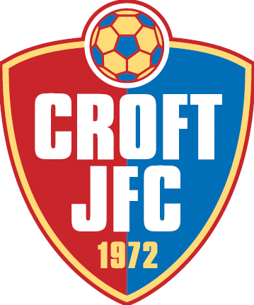
Croft Junior FC
Charity Tournament
Sat 30th and Sun 31st May 2015
Entry Form
Please provide your details for contact.
Club Name ……………………………… Affiliation No. (must be provided) ………………..
Tel. No. ………………………...........
Address ……………………………………………………………………………………………….............
Email (please write clearly)……………………………………...........................................
Saturday 30th May 2015
Under 7’s (10.00am -12.00pm) Number of Teams (£40 each) ................ Total ...............
Under 8’s (10.00am -12.00pm) Number of Teams (£40 each) ................ Total ...............
Under 9’s (12.30pm -14.30pm) Number of Teams (£40 each) ................ Total ...............
Under 10’s (12.30pm -14.30pm) Number of Teams (£40 each) .............. Total ...............
Under11’s (15.00pm -17.00pm) Number of Teams (£40 each) .............. Total ...............
Under 12’s (15.00pm -17.00pm) Number of Teams (£40 each) .............. Total ...............
Sunday 31st May 2015
Under 13’s (10.00am -12.00pm) Number of Teams (£40 each) .............. Total ...............
Under 14’s (10.00am -12.00pm) Number of Teams (£40 each) ..............Total ...............
Under 16’s (12.30pm -14.30pm) Number of Teams (£40 each) ...............Total ...............
Under 18’s (12.30pm -14.30pm) Number of Teams (£40 each) .............. Total ...............
Under 15’s (15.00pm -17.00pm) Number of Teams (£40 each) .............. Total ...............
Total amount submitted....................................
Please make cheques payable to Croft JFC and send to Mark Slade at 76 Caulfield Road, Swindon, Wilts, SN2 8BT. Alternatively should you require to pay by BACS then please request details via email.
Confirmation of entry will be sent by email once received and raffle tickets sent out once we have received payment.

