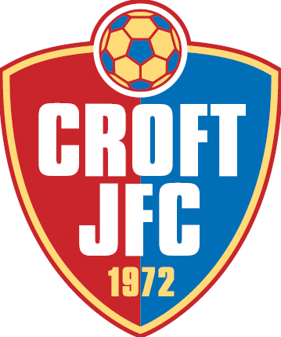
Croft Junior FC
Charity Tournament
Sat 30th and Sun 31st May 2015
It’s a not a choice but a must because:

- It’s aimed at being both a Fun and Enjoyable Festival of Football for all ages from U7’s through to U18’s.
- There is a Guaranteed Semi Final for all Teams irrespective of League positions.
- As well as Main Trophies and Plate Finals there is also the chance of a Chairman’s Trophy too, so the possibility of playing for 3 Trophies dependant on numbers. (Max 12 per age group for this extra award). This is a Festival of Football and all are welcomed as such. Every team will have the chance of winning some sort of Trophy.
- All Development Age Groups (U7 to U10) will compete for the same Trophies, as above, however Medals will be awarded to all who do not win the main individual awards, as such a combination of Trophy Events and Non Competitive so no one loses out and our confirmation of Development for all concerned.
- It’s the most cost effective Tournament around.
- No other Tournament supports Prospect Hospice and last year we raised £1000.00 for them.
- Free parking and Programmes on sale at a cost of just £1.00.
- Many Raffle prizes available due to numerous donations.
Who else offers the same?
Our aim is for the Tournament to be both Friendly and Competitive for ALL, with FUN for every team who participate, and with the opportunity to WIN something regardless of ability, as this is both the Club’s message and ethos.
Times and days for the Age groups are as follows:
Saturday 30th May
Sat (10.00-12.00) U7's and U8's
Sat (12.30-2.30) U9's and U10's
Sat (3.00-5.00) U11's and U12's
Sun 31st May
Sun (10.00-12.00) U13's and U14's
Sun (12.30-2.30) U16's and U18's
Sun (3.00-5.00) U15's
For further info please contact treasurer@croftjfc.co.uk or visit http://croftjfc.co.uk/football-tournament-2015/ as all docs and rules are available to see/download. We hope to hear back from you soon to avoid disappointment as places are filling fast.
Regards
Croft Organising Committee

